**CMPUT 366 HOMEWORK 1**

Explaining the Results:

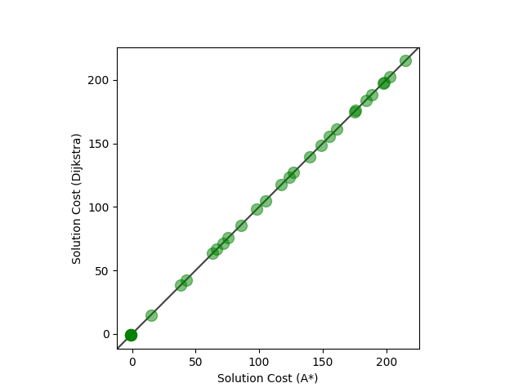

According to the pictures, the solutions given by the Dijkstra’s Algorithm is identical to the A* Algorithm, of which we can conclude that using either of the algorithms will give the same solution.

However, Dijkstra’s Algorithm will expand significantly more nodes compared to A* Algorithm (By using the inputs given by this Assignment, we can see Dijkstra’s Algorithm expanded more nodes than A* Algorithm by a factor of $10$ s on average). As a result, the running time for Dijkstra’s Algorithm will be significantly longer than A* Algorithm, sometimes can be up to a factor of $10$ s.

Multiplicative Factor:

It is clear from the graph that this new A* Algorithm will expand significantly less nodes compared to the old A* Algorithm, hence this new A* Algorithm will run much faster than the old A* Algorithm (and the old one is already much faster than Dijkstra’s Algorithm). However, the new A* Algorithm produces slightly different answer compared to the old A* Algorithm (and Dijkstra’s Algorithm).

When we inflate the heuristic function by $2$, then there is a chance that there exist some nodes in the tree such that $h_{2}\left(n\right)>h^{*}\left(n\right)$ ($h_{2}\left(n\right)=2⋅\left(n\right)$). This means $h_{2}\left(n\right)$ is likely non-admissible and thus unlikely to have an optimal solution.

The reason we find the goal node so quickly and expand significantly less nodes compared to the old A* Algorithm is because the A* Algorithm depends on $f\left(n\right)=g\left(n\right)+h\left(n\right)$, and when we inflate $h\left(n\right)$, $f\left(n\right)$ will depends more on $h\left(n\right)$, which means the algorithm will move quicker to the goal (more “greedy”) – because as we move to the correct direction, $h\left(n\right)$ will decrease, but since now $h\left(n\right)$ is double as before, $h\left(n\right)$ now will decrease two times as quickly, which means $f\left(n\right)$ will decrease much faster.